**Canton class have been learning to play Samba!**

[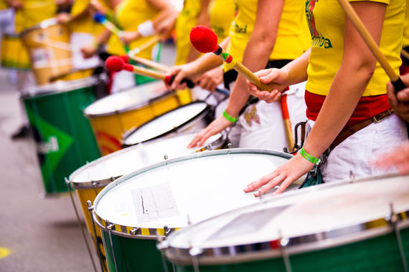](https://www.google.co.uk/url?sa=i&source=images&cd=&cad=rja&uact=8&ved=2ahUKEwi7jsjqmPvaAhWFcRQKHQTmA-YQjRx6BAgBEAU&url=https://www.normans.co.uk/blog/2014/07/world-drums-samba-drums/&psig=AOvVaw2viofz0NPIiGJK-Elv9S1W&ust=1526043399031740)

We will be putting on a performance in school and would like to invite you to come and watch.

The performance will be on Tuesday 16th October at 11.00am. We hope you can make it!